DataFrame Reader API is used to read the file
Q HOW TO GET PATH OF FILE PATH
dbutils.fs.ls('/FileStore/tables')
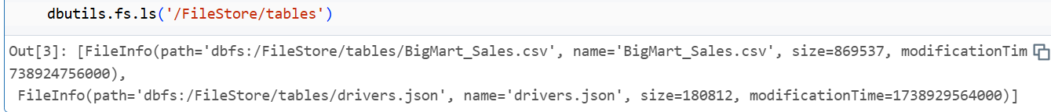

Q how to load and view the data
df=spark.read.format('csv').option('inferSchema',True).option('header',True).load('/FileStore/tables/BigMart_Sales.csv')

What is infer_schema?
INFER_SCHEMA is a table function which returns the above columns and the data for those columns are the column names of the file including additional information like data type of the file column and the order of the column in the file

where spark.read is used to read the file “format” is used to see the format type of the document
“.option” refers to a way to specify additional parameters or settings when interacting with data , particularly when reading or writing data from different file formats like CSV, JSON, or Parquet, allowing you to customize how the data is processed based on specific options like delimiters, header rows, or data type conversions; essentially, it's a key-value pair where the "key" is the option name and the "value" is the desired setting for that option.
.option('header',True) is used to see the column name or it will conside it also as row
.load to load the data from path file in Filestore

Q to view the data of the csv file
df.display()
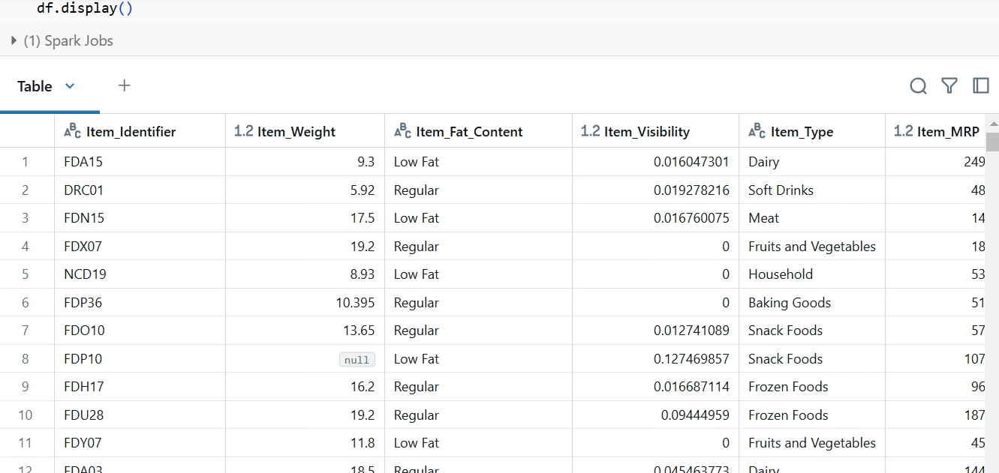

Q to print the schema of our data we use where as schema is generally the column type ex: String,int,date
df.printSchema()
Q to read the json file
df_json=spark.read.format('json').option('inferSchema',True)\
.option('header',True)\
.option('multiline',False)\
.load('/FileStore/tables/drivers.json')

Q to display json file
df_json.display()
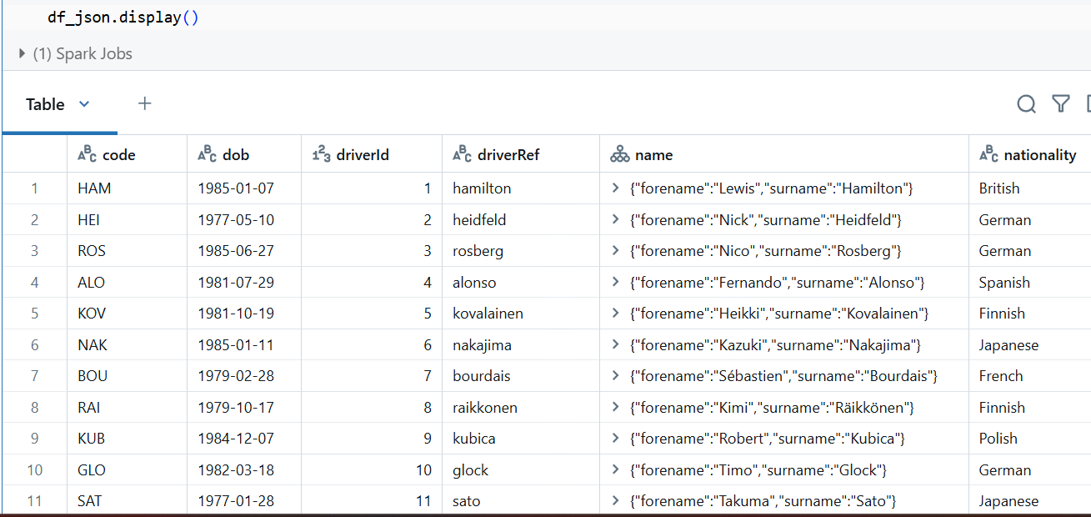

TRANSFORAMTION

Q if we don’t want infer schema we can define our own schema using -DDL and StructType()

Q to print our document schema we use
df.printSchema()
where schema is generally the definition of our table that is type of column name is int ,String ,date
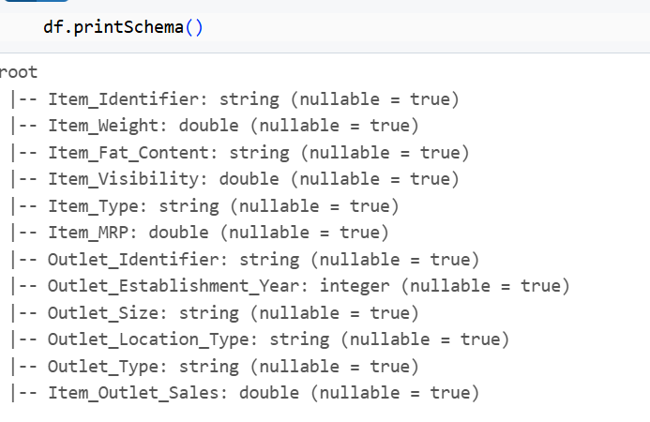
Method 1 using DDL TO CHANGE THE SCHEMA
Q to change the datatype of ITEM_WEIGHT to String we use
my_ddl_Schema= '''
Item_identifier STRING,
Item_Weight STRING,
Item_Fat_Content STRING ,
Item_Visibility DOUBLE,
Item_Type STRING ,
Item_MRP DOUBLE,
Outlet_Identifier STRING ,
Outlet_Establishment_Year integer,
Outlet_Size STRING,
Outlet_Location_Type STRING ,
Outlet_Type STRING,
Item_Outlet_Sales DOUBLE
'''

Q we have to do changes in reader API to pass the schema
df=spark.read.format('csv')\
.schema(my_ddl_Schema)\
.option('Header',True)\
.load('/FileStore/tables/BigMart_Sales.csv')
And then call and then display it

df.display()
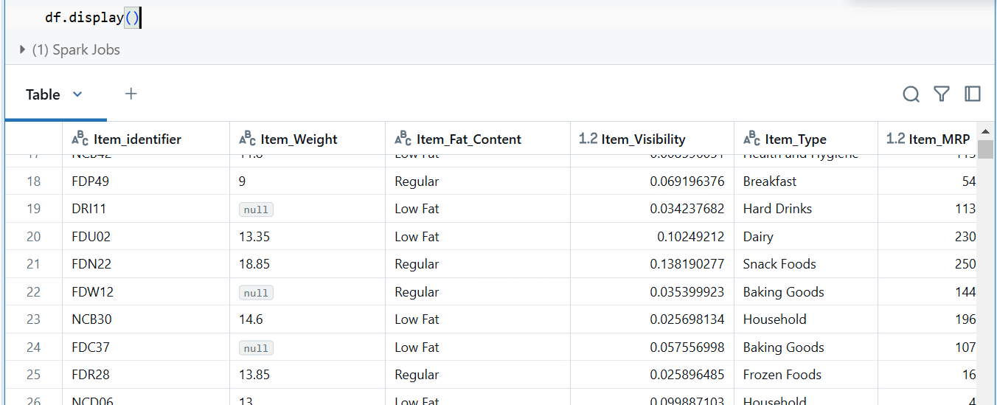

To check the schema we use
Df.printSchema()
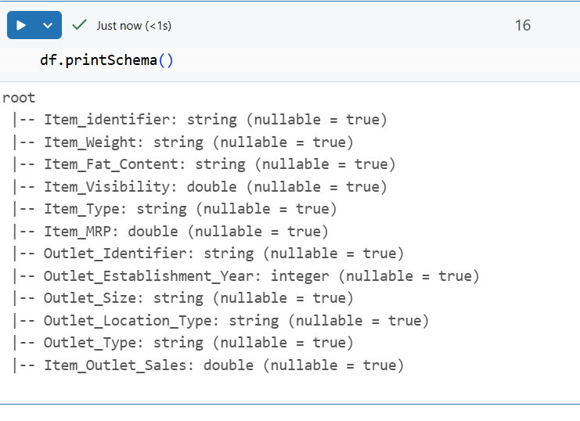
Using another method to change the schema

Method 2 using StructType to change the Schema

my_strct_schema = StructType([
StructField('Item_identifier',StringType(),True),
StructField('Item_Weight',StringType(),True),
StructField('Item_Fat_Content',StringType(),True),
StructField('Item_Visibility',StringType(),True),
StructField('Item_Type',StringType(),True),
StructField('Item_MRP',StringType(),True),
StructField('Outlet_Identifier',StringType(),True),
StructField('Outlet_Establishment_Year',StringType(),True),
StructField('Outlet_Size',StringType(),True),
StructField('Outlet_Location_Type',StringType(),True),
StructField('Outlet_Type',StringType(),True),
StructField('Item_Outlet_Sales',StringType(),True),

])

df=spark.read.format('csv')\
.schema(my_strct_schema)\
.option('header',True)\
.load('/FileStore/tables/BigMart_Sales.csv')
df.printSchema()
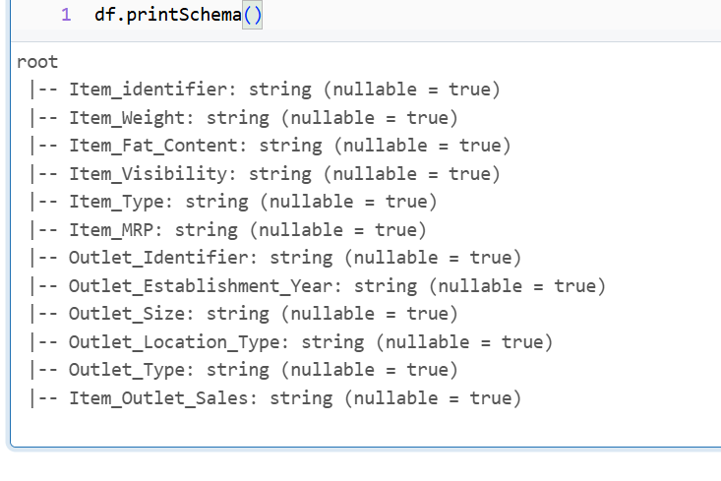

Q transformation for using only Select Statement
There are multiple ways to call the data
- Using simple way using “.select”
df_sel=df.select('Item_identifier','Item_weight','Item_Fat_Content').display()
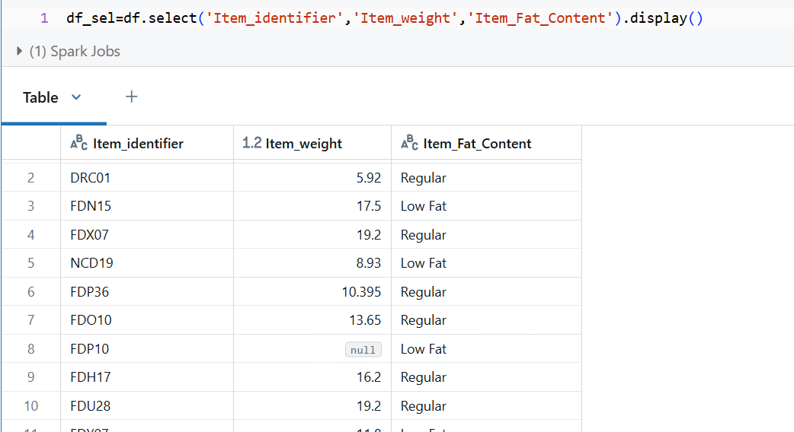

- Using col() function to call the data
df.select(col('Item_Identifier'),col('Item_Weight'),col('Item_Fat_Content')).display()

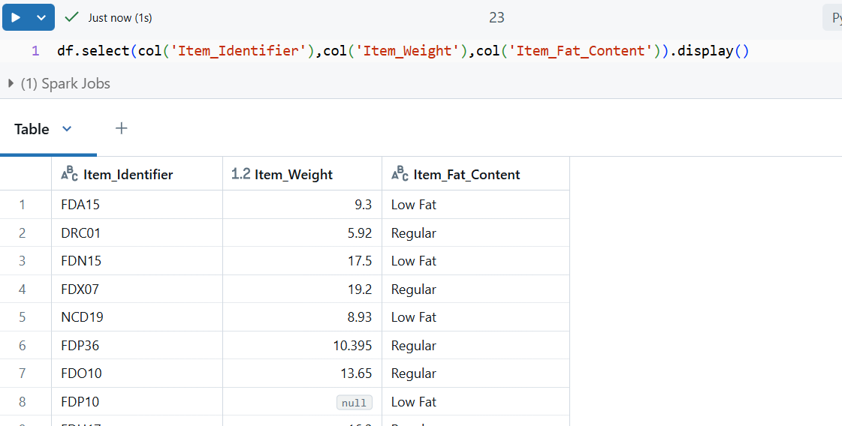

Q transformation using Allias as transformation
df.select(col('Item_identifier').alias('item_ID')).display()
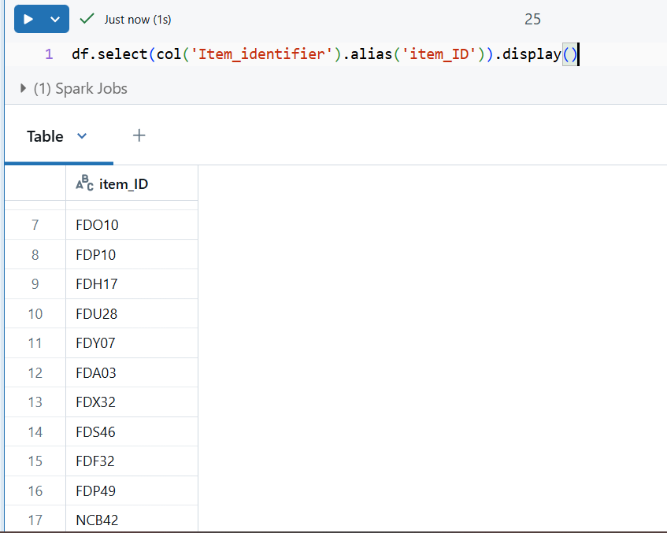

### Filter
Q using Transformation using Filter/Where condition
Scenario 1
Q Where fat content is Regular
df.filter(col('Item_Fat_Content')=='Regular').display()
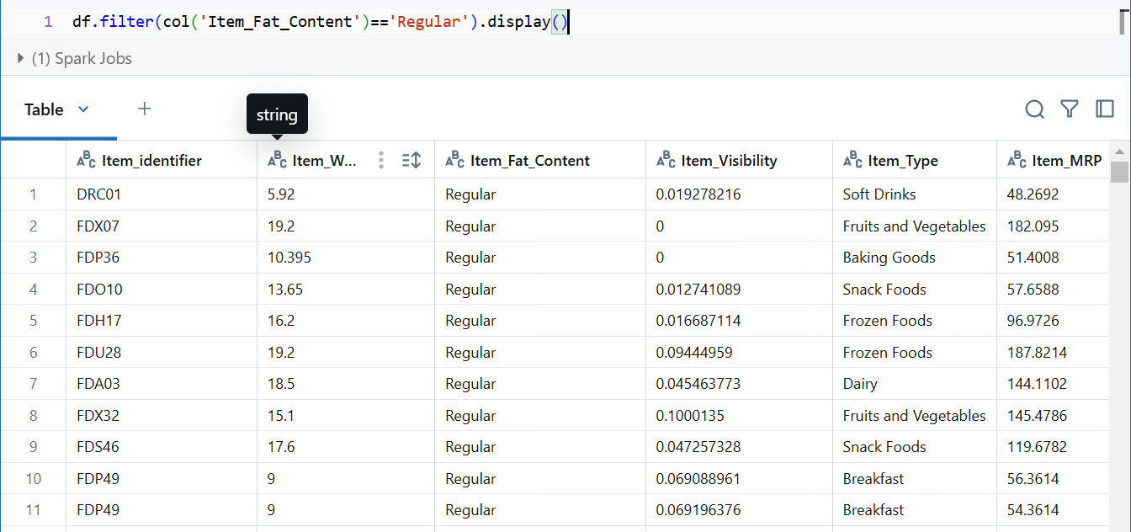

Scenario 2
df.filter((col('Item_type')=='Soft Drinks') & (col('Item_Weight')<10)).display()
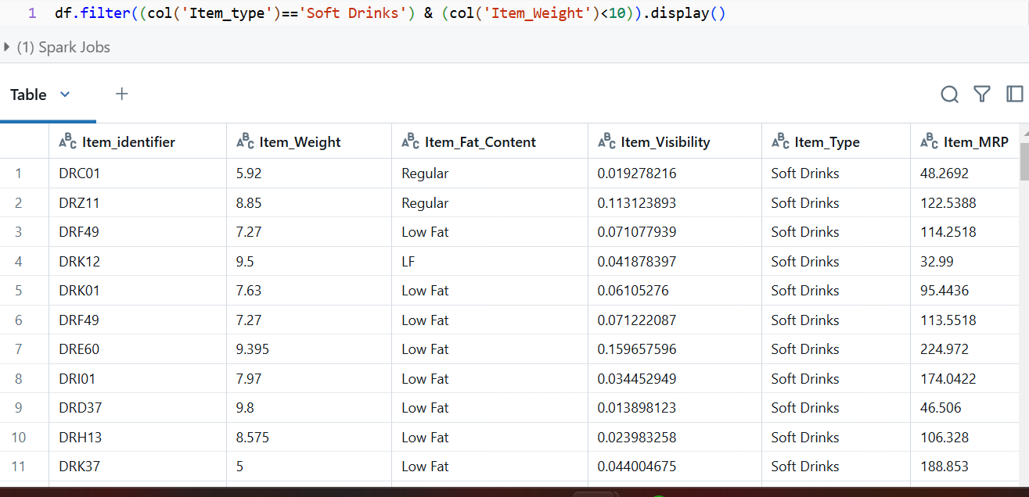

Scenario 3
Where we have to use multiple value in same row and another row value where scolumn value is NULL
Functions
.isin() where we can fetch multiple value from the same row same ass in operartor
.isNull() we can use when we wat to fetch null value

Q Fetch value of tier 1, Tier 2 and Outlet_size is null
df.filter((col('Outlet_Size').isNull()) & (col('Outlet_Location_Type').isin('Tier 2','Tier 2'))).display()

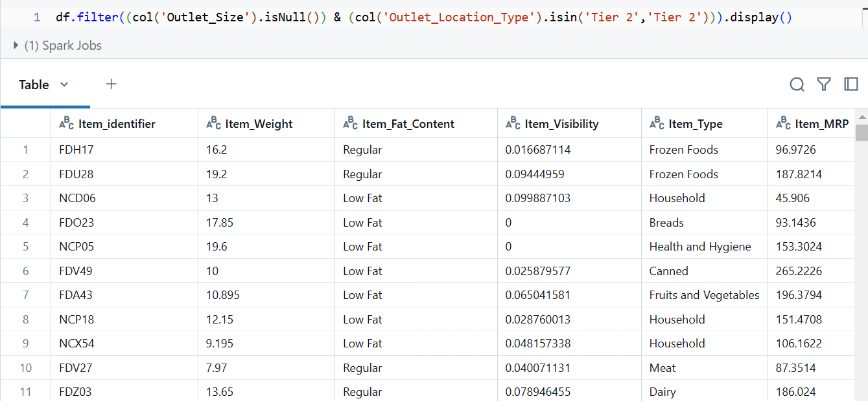

Transformation with column name
Q rename the column Item_Weight to Item_WD
df.withColumnRenamed('Item_Weight','Item_wd').display()
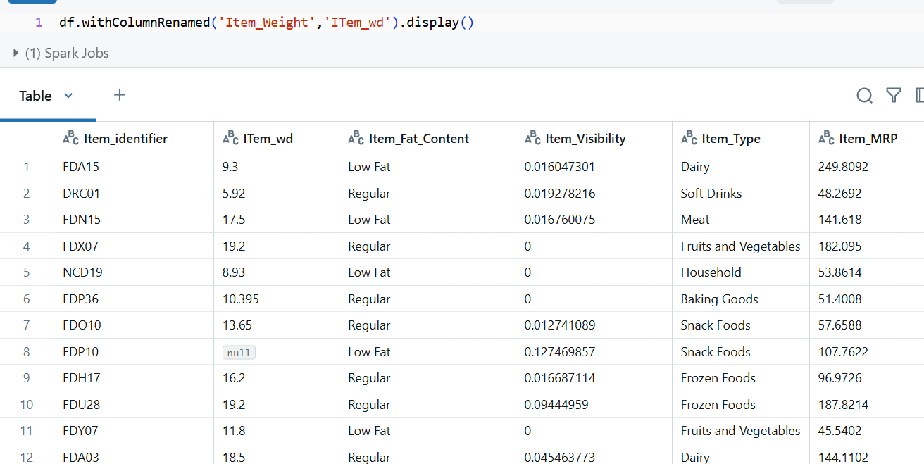

- WithColumn
To add new column and modify existing column
Scenario 1 to add new column
df=df.withColumn('flag',lit("new"))
df.display()
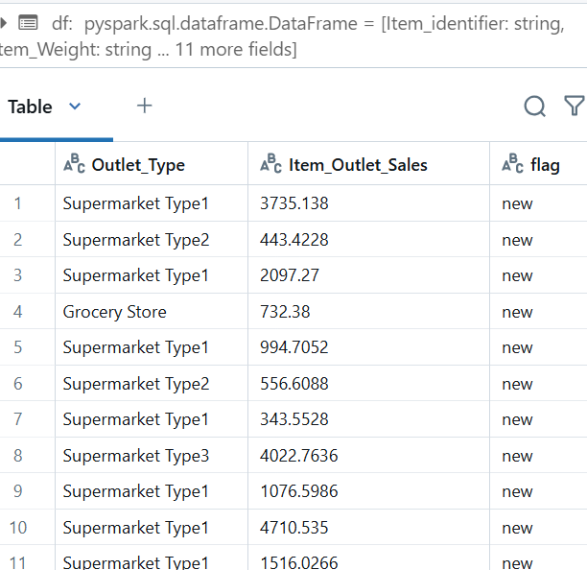

Q Product of item_weight and item_mrp
df.withColumn('multiply',col('Item_Weight')*col('Item_MRP')).display()

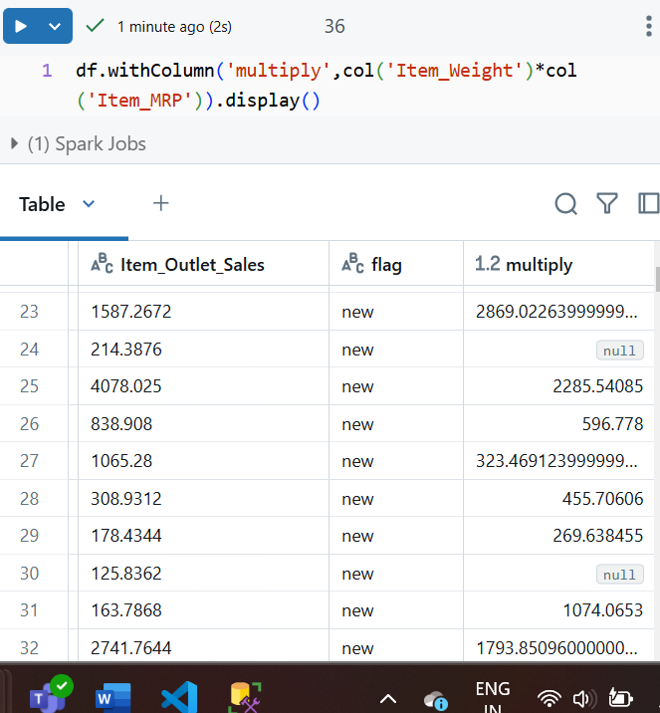

Q change the values in Item_fat_Content where Lowfat as Lf and regulae reg
##regexp_replace() to replace the column value with something else
df.withColumn('Item_Fat_Content',regexp_replace(col('Item_Fat_Content'),"Regular","Red")) \
.withColumn('Item_Fat_Content',regexp_replace(col('Item_Fat_Content'),"Low Fat","LF")).display()
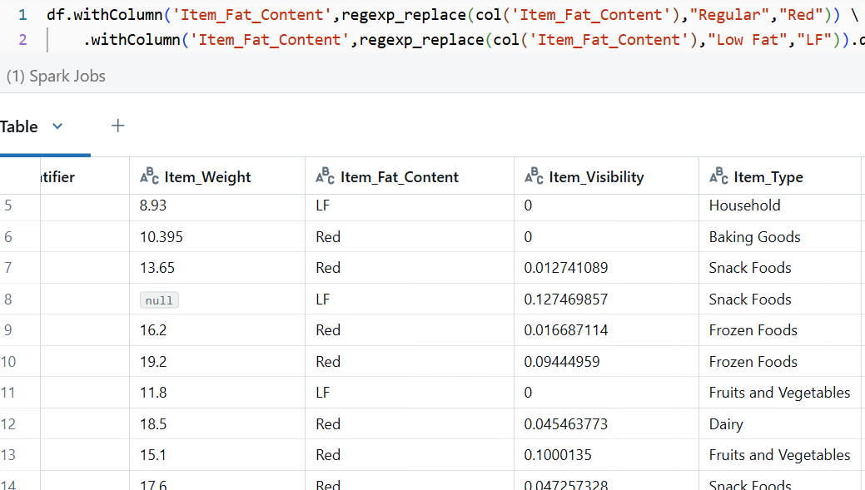

### TypeCast operator
df=df.withColumn('Item_Weiight',col('Item_Weight').cast(StringType()))
df.printSchema()

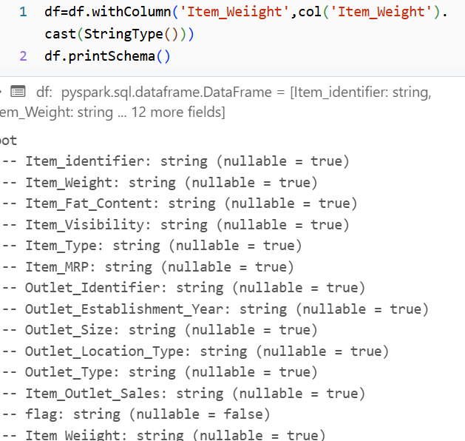

- Sort/ OrderBY
Sort.asc()/,desc()

df.sort(col("Item_Weight").desc()).display()
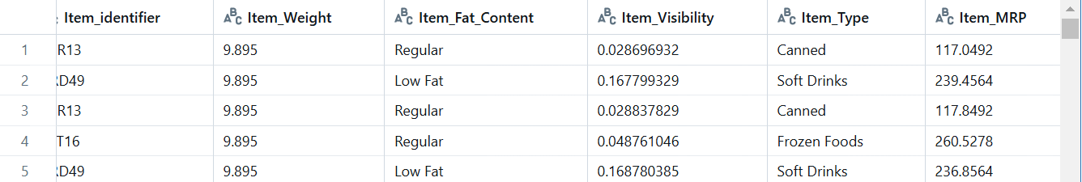

Scenario 2 multiple column sorting with different values where both columns are ascending
df.sort(['Item_Weight','Item_Visibility'],ascending=[0,0]).display()
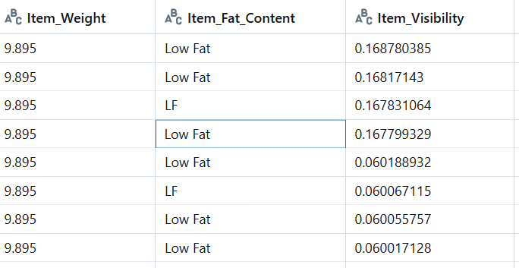

Scenario 3 where one column is ascending and other is descending

df.sort(['Item_Weight','Item_Visibility'],ascending=[1,0]).display()
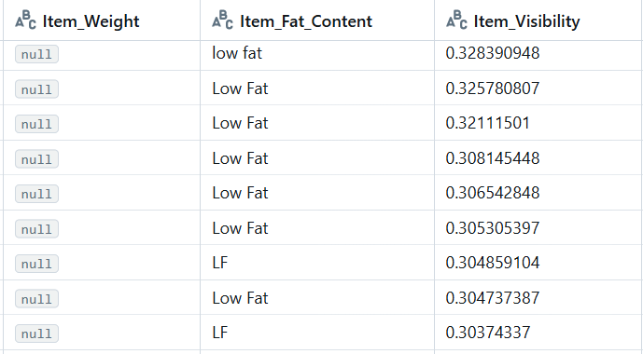

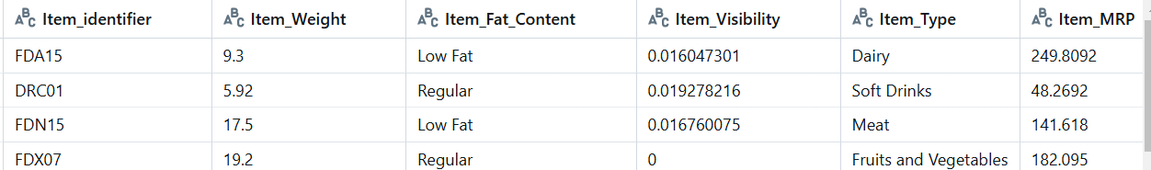To get only few records instead of all those record

DROP

We can drop single column or multiple column
df.drop("Item_Visibility").display()
df.drop("Item_Visibility","Outlet_type").display()

Drop_duplicates
Description all column will only have unique values
df.drop_duplicates(subset=["Item_type"]).display()

Distinct()
df.distinct().display()
gave only unique row values same as Drop()

Union() and Union BY Name()

data1=[("1","Kad"),
("2","sid")]
Schema1="id STRING,name STRING"
df1=spark.createDataFrame(data1,Schema1)
data2=[("3","rahul"),
("4","jas")]
Schema2="id STRING,name STRING"
df2=spark.createDataFrame(data2,Schema2)
df1.display()
df2.display()

df1.union(df2).display()
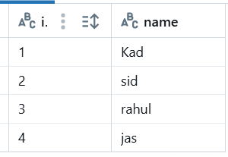
Union will just add all the rowa with =out checking the order
data1=[("Kad","1"),
("sid","2")]
Schema1="name STRING,id STRING"
df1=spark.createDataFrame(data1,Schema1)
data2=[("3","rahul"),
("4","jas")]
Schema2="id STRING,name STRING"
df2=spark.createDataFrame(data2,Schema2)
df1.union(df2).display()
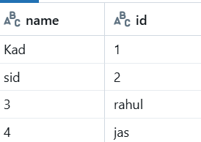

#thats why we use unionByName
It will union the column by column name rather than mixing up the data

df1.unionByName(df2).display()

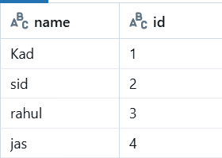

#### STRING FUNCTIONS

1)INITCAP()
2)LOWER()
3)UPPER()
df.select(initcap("Item_Type")).display()
df.select(lower("Item_Type")).display()
df.select(upper("Item_Type")).display()

#### DATE FUNCTIONS
1)Current_Date()
df=df.withColumn("curr_date",current_date())

2)date_add()
df=df.withColumn("Week_after",date_add("curr_date",7))
df.display()
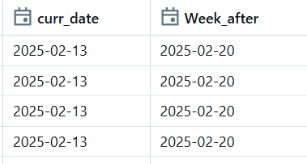

3)date_sub()
df.withColumn("Week_after",date_sub("curr_date",7)).display()
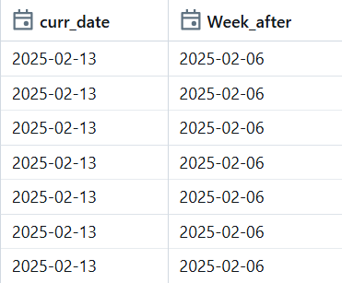

- DATE_DIFF(new_date,before_date)
df=df.withColumn("date_diff",date_diff(df.curr_date,df.week_before)).show()
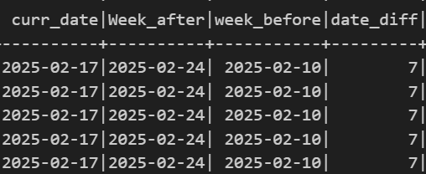

- DATE_FORMAT
result=df1.withColumn("week_before",date_format("week_before","dd-MM-yyyy"))
result.show()
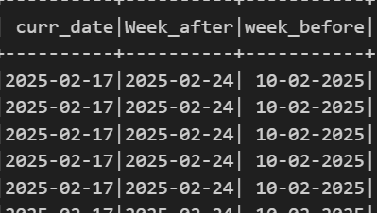

HANDLING NULLS

DROPPING NULLS
# result=df.dropna('all')

result=df.dropna('any')
result.display()

“all” will delete the row where all the row contains null value
Where as “any” will delete any record which consist null value

## dropping null value only for specific column

result=df.dropna(subset="Outlet_Size")
result.display()
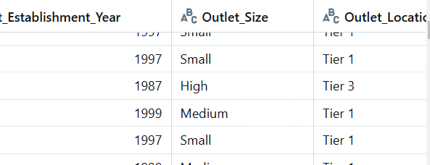

# Filling null values only on particular column using subset
result=df.fillna("NotAvailable",subset=["Item_Weight"])
result.display()

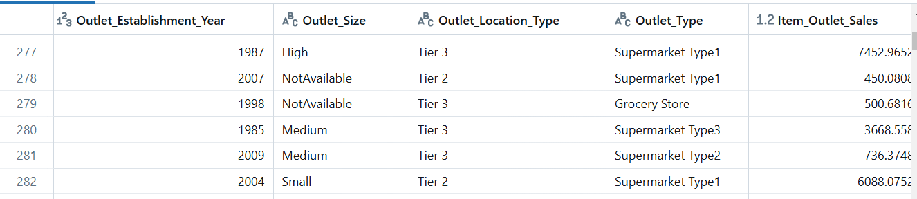

SPLITTING and INDEXING
SPLIT()
result=df.withColumn("Outlet_Type",split("Outlet_Type"," "))
result.display()
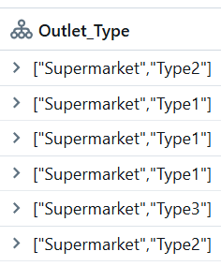

Indexing
result=df.withColumn("Outlet_Type",split("Outlet_type"," ")[1])
result.display()
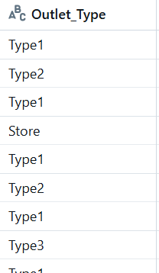

Explode()
result=df_exp.withColumn("outlet_type",explode("outlet_type")).display()
result.display()
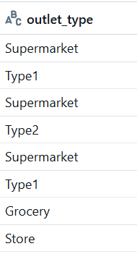

Array_contains()
result=df_exp.withColumn("type_flag",array_contains("Outlet_Type","Type1"))
result.display()
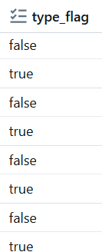

GROUP BY
df.groupBy("Item_type").agg(sum("Item_MRP")).display()
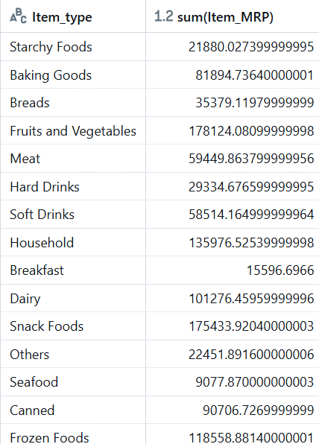

Scenario 2 multiple columns
result=df.groupBy("Item_type","Outlet_size").agg(sum("Item_mrp").alias("mrp"))
result.display()
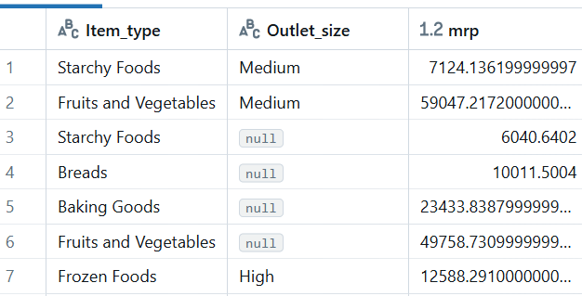

Scenario 3
Multiple aggregrate functions
result=df.groupBy("Item_type","Outlet_size").agg(sum("Item_mrp").alias("mrp"),avg("item_mrp"))
result.display()
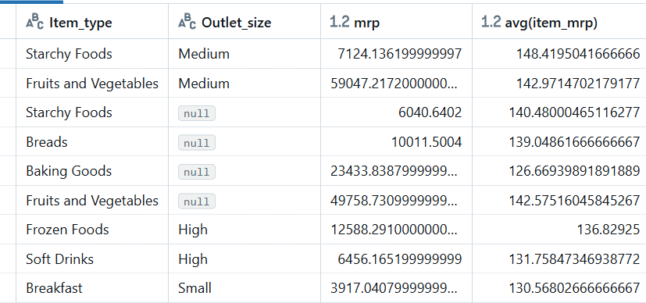

collect_list

result=df_book.groupBy("user").agg(collect_list("book"))
result.display()
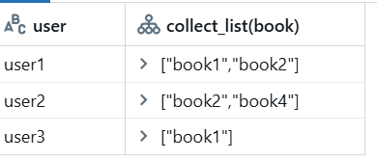
PIVOT
result=df.groupBy("Item_type").pivot("outlet_size").agg(avg("item_mrp")).display()
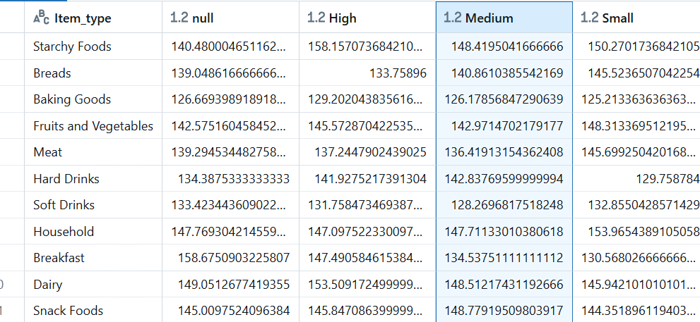

WHEN-OTHERWISE/CASE WHEN
Scenario 1
result=df.withColumn("veg_flag",when(col("item_type")=="Meat","non_veg").otherwise("veg"))
result.display()
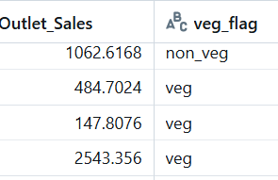

Joins

dataj1 = [('1','gaur','d01'),
('2','kit','d02'),
('3','sam','d03'),
('4','tim','d03'),
('5','aman','d05'),
('6','nad','d06')]

schemaj1 = 'emp_id STRING, emp_name STRING, dept_id STRING'

df1 = spark.createDataFrame(dataj1,schemaj1)

dataj2 = [('d01','HR'),
('d02','Marketing'),
('d03','Accounts'),
('d04','IT'),
('d05','Finance')]

schemaj2 = 'dept_id STRING, department STRING'

df2 = spark.createDataFrame(dataj2,schemaj2)
df1.show(),df2.show()

Inner joins

df1.join(df2,df1.dept_id==df2.dept_id,"inner").show()
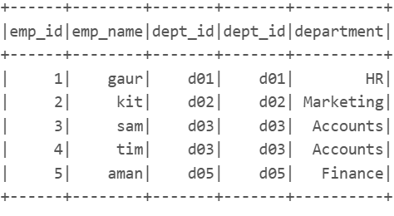

Left Join
df1.join(df2,df1.dept_id==df2.dept_id,"left").display()

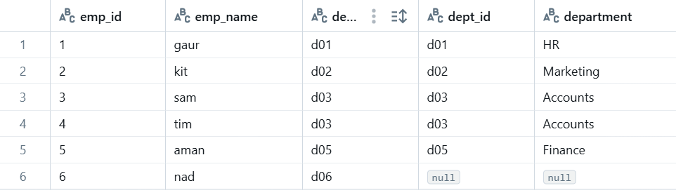

Right outer join
df1.join(df2,df1.dept_id==df2.dept_id,"right").show()
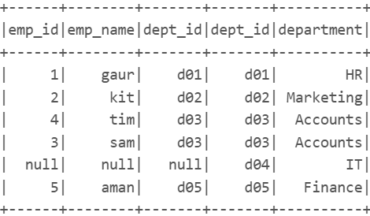

Anti-Join
df1.join(df2,df1.dept_id==df2.dept_id,"anti").show()
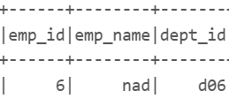

WINDOW FUNCTIONS

Row Number()
df.withColumn("rowcol",row_number().over(Window.orderBy("Item_Identifier"))).display()

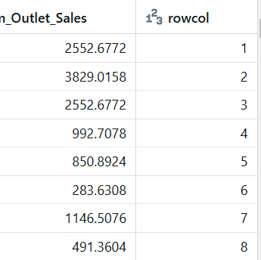

RANK
result=df.withColumn("rank",rank().over(Window.orderBy("Item_Identifier")))
result.display()
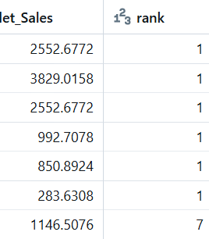

dense_rank
result=df.withColumn("rank",rank().over(Window.orderBy("Item_Identifier")))\
.withColumn("Dense_rank",dense_rank().over(Window.orderBy("Item_Identifier")))
result.display()

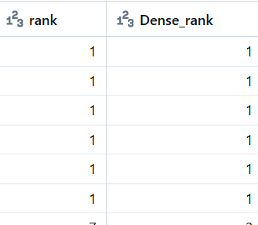

Cumulative Sum
df.withColumn("cumSum",sum("Item_MRP").over(Window.orderBy("item_type").rowsBetween(Window.unboundedPreceding,Window.currentRow))).display()
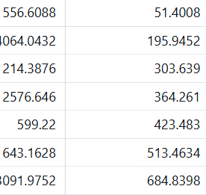

USER DEFINED FUNCTIONS

# def my_func(x):
# return x*x
# my_udf = udf(my_func)
# df.withColumn('mynewcol',my_udf('Item_MRP')).display()

Data Writing

CSV
df.write.format("csv")\
.save("/FileStores/tables/csv/data.csv")

APPend
df.write.format('csv')\
.mode('append')\
.save('/FileStore/tables/CSV/data.csv')

df.write.format('csv')\
.mode('append')\
.option('path','/FileStore/tables/CSV/data.csv')\
.save()

Overwrite

df.write.format('csv')\
.mode('overwrite')\
.option('path','/FileStore/tables/CSV/data.csv')\
.save()

ERROR
df.write.format('csv')\
.mode('error')\
.option('path','/FileStore/tables/CSV/data.csv')\
.save()

Ignore
df.write.format('csv')\
.mode('ignore')\
.option('path','/FileStore/tables/CSV/data.csv')\
.save()

SPARK SQL

df.createTempView('my_view')

In [0]:

%sql

select * from my_view where Item_Fat_Content = 'Lf'

In [0]:

df_sql = spark.sql("select * from my_view where Item_Fat_Content = 'Lf'")

In [0]:

df_sql.display()

#CODE START
import os
import time
from pyspark import SparkConf
from pyspark.sql import SparkSession
jars_dir = os.path.join(os.getcwd().replace("src", ""), "jars")
print(jars_dir )
jdbc_driver_path = [os.path.join(jars_dir, i) for i in os.listdir(jars_dir)]
print(jdbc_driver_path )
jdbc_driver_path = ",".join(jdbc_driver_path)
print(jdbc_driver_path )
start_time = time.time()

conf = SparkConf().setMaster("local[*]").set("spark.sql.debug.maxToStringFields", 1000) \
.set("spark.executor.heartbeatInterval", 200000) \
.set("spark.network.timeout", 300000) \
.set("spark.sql.execution.arrow.pyspark.enabled", "true") \
.set("spark.jars", jdbc_driver_path) \
.set("spark.ui.port",4040) \
.set("spark.driver.cores", "5") \
.set("spark.executor.cores", "5") \
.set("spark.driver.memory", "1G") \
.set("spark.executor.memory", "1G") \
.set("spark.executor.instances", "2") \
.setAppName("PYSPARK_MSSQL")
spark = SparkSession.builder.config(conf=conf).getOrCreate()
sc = spark.sparkContext
sc.setLogLevel("WARN")
db_ip = "localhost"
db_name = "master"
table_name = "BigMart_Sales"
auth_library_path = "C:/Users/verac/Downloads/pyspark_mssql/pyspark_mssql/jars/mssql-jdbc_auth-12.8.1.x64.dll"
# Update java.library.path
os.environ["java.library.path"] = auth_library_path
driver = "com.microsoft.sqlserver.jdbc.SQLServerDriver"
jdbc_url = "jdbc:sqlserver://{};databaseName={};integratedSecurity=true;".format(db_ip, db_name)
df=spark.read.format("jdbc").option("url",jdbc_url).option("driver",driver).option("dbtable",table_name).load()

df.write \
.format("jdbc") \
.option("driver", driver) \
.option("url", jdbc_url) \
.option("dbtable", table_name + "_LiveStream") \
.option("isolationLevel", "NONE") \
.option("rewriteBatchedStatements", "true") \
.mode("overwrite") \
.save()

